Final Year Project Report
(Research Based)

Project Name


Project Advisor:

Submitted By:

Session

2018-2023
BS SE

University of Management and Technology

C-II Johar Town Lahore Pakistan

Dedication

Final Approval

Panel of Examiners

- Head of Department ______________________
Department of Software Engineering
University of Management and Technology,
Lahore

- Program Director ( Final Year Projects) ______________________
Department of Software Engineering
University of Management and Technology,
Lahore

- Supervisor ______________________
Department of Software Engineering
University of Management and Technology,
Lahore

- Co-Supervisor ______________________

Acknowledgements

In the name of Allah, the Compassionate, the Merciful. All praise be to Allah, the Lord of universe and peace and blessing upon Prophet Muhammad (P.B.U.H), and his household and noble companions.
We would like to thanks Allah Almighty who made us able to complete our final year project “Heart Disease Prediction System and Consultancy” with patience and hard work. After Allah Almighty we would like to thanks our project advisor “Mam Halima Jamil“ and our co advisor “Mam Maria Tauqeer” who helped us throughout the project with their guidance and mentorship. They shaped our project into a valuable product by their suggestions and quality feedback on our work continuously during last one year. We are also thankful to our department Software Engineering who gave us a quality environment for doing this project and for providing the needed equipment’s and facilities for doing this project.
A special thanks to our parents who supported us in this project journey for their prayers and love. We would like to thanks each other all three group members Abdullah, Ibtehaj ul Haq and Muhammad Kamran for the cooperation and collaboration for doing this successful project because without this type of great cooperative environment we could never able to complete this project.

Abstract
Heart Disease Prediction System and Consultancy is a web based project which is helpful in the detection of heart failure at the early stage by getting some details of patient related to heart disease by using the machine learning techniques. This system is specially designed for backward and remote areas where people are not well aligned with the checkup routine. They will give the basic parameters as input related to health like blood pressure, cholesterol level and heart rate. Patient will upload the detail after signup and then according to the detail our AI based system will work by machine learning model and tell them the heart failure risk and also suggest them the nearest doctor based on patient location for further checkup as it has doctor dashboard were online consultancy will also be provided. This system will make sure the effective interaction between doctor and patient. In conclusion this project will save the lives by alerting the patient based on its parameters and by giving them the solution in form of online checkup or by physical checkup from nearest doctor. It is a free of cost process till doctor consultancy as if you don’t have the heart failure risk then it will save your money of doctor visit.

Contents
New paragraphs formatted as Heading 1, Heading 2, and Heading 3 will be added to the table automatically. To update this table of contents in Microsoft Word, put the cursor anywhere in the table and press F9. If you want the table to be easy to maintain, do not change it manually.
• Final Year Project Report 1
• Project Name 1
• Project Advisor: 1
• Submitted By: 1
• Session 1
• 2018-2023 1
• 1
• 1
• University of Management and Technology 1
• C-II Johar Town Lahore Pakistan 1
• Dedication 2
• 2
• Final Approval 3
Acknowledgements 4
Abstract 5
Contents 6
Definitions and Acronyms 8
List of Figures 9
List of Tables 10
1 Introduction 11
1.1 Problem Overview Heart disease is the main reason of death overall the world due to unavailability of healthcare facilities in remote and backward ares. So people can never check the heart failure risk rate at earlt stages. We made this project to tackles the unavailability of accessible, accurate diagnostic tools for heart disease. It uses machine learning to predict heart disease risk and provides online consultancy with doctor recommendations and also give nearby doctor suggestions for physical checkup. 11
1.2 Research Questions 11
• Will machine laerning give the correct and effective heart disease risk by using health basic parameters ? 11
• Can it help people to check the heart disease risk easily from anywhere ? 11
1.3 Research Objectives 12
• To make a machine laerning and AI powered system that will get the health parameters and will predict the heart disease risk rate 12
• To make a user friendly system where user can get the istant result in easy way 12
• To make connection of doctor and patient online and suggestion of nearest doctor based on location of user for physical checkup 12
• To make the health report of the patient so doctor can make a valid decision regard of patient treatment and condition. 12
1.4 Scope This project focus on predicting heart failure risk by using basic health parametric matrics. It is a web interface for patients, doctors and helpful for online and physical consultancy after anylsing heart failure risk. The system will be secure platform, scalable and reliable. 12
• we have developed the te frontend by using html, css, javascript’s framework react and backend by using django python. 12
• we have integrated AI and machine learning model on heart disease conditions 12
• we have provided a chatbot for user interaction 12
• we have integrated online consultancy and location based doctor suggestion 12
• We have made a doctor dashboard where they can register them and see the patient report details 12
1.4 Methodology 13
1.5 Significance/ Potential Applications 13
2 Background 14
3 Literature review 15
• Gap Analysis 15
4 Proposed Methodology 17
• Suggested Approach 17
• Workflow of the system 17
• Algorithms/Architecture 18
5 Design and Implementation 19
• System Design 19
• System Implementation 19
• Assumptions/Constraints (Optional) 20
6 Evaluation 21
• Experimentation 21
6.1.1 Experimental Setup 21
6.1.2 Experiments Design/Details 21
• Results 21
• Discussion/Analysis 21
7 Conclusion and Future work 22
8 References/ Bibliography 23
9 Appendix 24
• Glossary of terms 24
• Pre-requisites 24
• Reference/ Source Documents 24

Definitions and Acronyms
Provide definitions or references to all the definitions of the special terms and acronyms used within this document.

CNN (Convolutional Neural Network)
Uses deep learning techniques to study and analyses visual images and patterns.

HTML (Hypertext Markup Language)
The foundational computer language that sets up the framework of websites.

CSS (Cascading Style Sheets)
Used for the aesthetic design of websites including colors, fonts, and layout structures.

React:
A web library written in JavaScript that allows the creation of dynamic and responsive web interfaces.

Django (Python)
A web framework for Python that allows the development of secure, reliable and scalable web applications.

Random Forest:
A term of the ml theory which refers to the algorithm that integrates a number of decision trees to produce a prediction.

Regression Tree:
A form of decision tree designed explicitly for predicting continuous quantitative variables.

PostgreSQL
A robust database management system that is freely available and is used for the storage and management of structured information.

SQLite:
A lightweight database that saves all its data in a single file. Ideal for small applications.

Google Cloud
A Google service providing hosting, cloud storage and machine learning services.

REST API (Representational State Transfer):
Provides a means for application programs to communicate over the internet such as web applications calling a server.

API (Application Programming Interface):
A software interface that enables two or more applications to interact by combining diverse computer programs.

NLP (Natural Language Processing):
This is a field of artificial intelligence aimed with making understanding and responding to human language possible for machines.

FAQs (Frequently Asked Questions):
These are standardized question and answer pairs created to assist users in resolving issues as fast as possible.

UI Interface:
The visual portion of a system, or what users click, type, and see on screen, is called the user interface, or UI.
ML:
Machine learning, or ML, is a branch of artificial intelligence in which computers learn from data and make decisions without explicit programming.
PEP8:
PEP8: A collection of guidelines for creating readable and clear Python code.
JSON:
JavaScript Object Notation, or JSON, is a format for data exchange and storage that is frequently used between frontend and backend systems.

List of Figures

New figures that are given captions using the Caption paragraph style will be added to the table automatically. To update this table of contents in Microsoft Word, put the cursor anywhere in the table and press F9. If you want the table to be easy to maintain, do not change it manually.
This section can be deleted if the document contains no figures or if otherwise desired.

List of Tables

Introduction

Heart disease is the leading cause of death worldwide due to not having particularly heart checkup often in the backward and remote areas where people don’t have proper health care system. Heart Disease Prediction System and Consultancy is made to detect the heart failure risk at early stage by using machine learning and AI models to make alert the patient to have a proper checkup to avoid any unwanted situation. This system will allow users to input the data in form of health related parameters like blood pressure, cholesterol level, heartbeat rate and then it will give the output result as risk rate of heart failure. If the patient will have risk, then it will also suggest the online consultancy and physical checkup from nearest doctors based on location. It will also have a doctor dashboard where doctor can register them and have patients for checkup. We used patient data to train our machine learning models like decision trees and random forests which make user friendly website. Our aim is to give the facility for early detection of heart failure risk free of cost so we can save the lives up to possible ratio.

Problem Overview
Heart disease is the main reason of death overall the world due to unavailability of healthcare facilities in remote and backward ares. So people can never check the heart failure risk rate at earlt stages. We made this project to tackles the unavailability of accessible, accurate diagnostic tools for heart disease. It uses machine learning to predict heart disease risk and provides online consultancy with doctor recommendations and also give nearby doctor suggestions for physical checkup.

Research Questions

Will machine laerning give the correct and effective heart disease risk by using health basic parameters ?

Can it help people to check the heart disease risk easily from anywhere ?
- Can this system connect the patient and doctor effectively?
- Will this system improve the early detection of heart disease and further follow-up?

Research Objectives

To make a machine laerning and AI powered system that will get the health parameters and will predict the heart disease risk rate

To make a user friendly system where user can get the istant result in easy way

To make connection of doctor and patient online and suggestion of nearest doctor based on location of user for physical checkup

To make the health report of the patient so doctor can make a valid decision regard of patient treatment and condition.

1.4 Scope
This project focus on predicting heart failure risk by using basic health parametric matrics. It is a web interface for patients, doctors and helpful for online and physical consultancy after anylsing heart failure risk. The system will be secure platform, scalable and reliable.

we have developed the te frontend by using html, css, javascript’s framework react and backend by using django python.

we have integrated AI and machine learning model on heart disease conditions

we have provided a chatbot for user interaction

we have integrated online consultancy and location based doctor suggestion

We have made a doctor dashboard where they can register them and see the patient report details

Methodology
Heart Disease Prediction System and Consultancy used the following methodologies:
- We collected the health related data sets from public sources like kaggle having details of patient like age, blood pressure, cholesterol level, heartbeat etc. and then make cleaning of incorrect data and fill the missing data.
- For data analysis we used machine learning models like decision tree, random forest and CNN model to find the heart failure risk
- We used agile method for software development as we developed it in stages. We made frontend in react, and backend by using Django python and hosted it on google cloud platform

Significance/ Potential Applications
- Heart Disease Prediction System and Consultancy is the effective solution for detecting heart failure risk at early stages in remote and backward areas where people don’t have good access on health care system.
- It can save the money and time for visiting hospital before detection of heart disease risk
- It can be easily used in mobile or other devices for online risk analysis and checkup
- Doctor can use it for interaction of patients and also can check the patient reports to make a quick decision
- Hospital can use it for diagnosis of heart failure and disease risk and can carry continuous monitoring.

Background
Heart disease is the leading cause of death worldwide due to not having particularly heart checkup often in the backward and remote areas where people don’t have proper health care system. This lead to late detection of the disease which cause the more death rate ratio. In the era of advancement by using AI and ML models we can predict the risk of heart failure by getting the patient details like blood pressure, cholesterol level, age factor, and heartbeat. This project is helpful in detection of the risk and also suggest the nearest doctor for visit and appointment if risk detected and also provide the online consultancy facility for patient to save time of patient for visit. It also gives pre detection free of cost just seeing your report details.
The aim of this project is to make a user friendly platform for checking heart disease detection and predicting its risk where user data and doctor’s data will be secured and system will be easy to use for those who don’t have much interaction with online systems so all type of user can access easily this system.

Literature review
Many researchers have worked on heart disease prediction system. It tells that models like Random forest, Decision tree are useful in early detection and prediction of heart failure by using patient data. These model achieved 80%-90% accuracy which depends upon the feature and datasets used.
For example, the Framingham Heart Study predicted the patient heart related issues and then many other researchers improved this study by using AI systems. This type of studies encourages us to build our system that predict real time risk and also helpful to connect doctor and patient.
The literature review made us able to make such an effective system which predict the real time outcomes. Also this is important because it carry technology and health on same page to save the lives and money of people who are not getting proper and timely health checkup living in backward and remote areas where medical facilities are less than required. Also this is helpful for busy routine people who don’t get much time for their healthcare.

Gap Analysis
Existing research paper and heart prediction system gave good accuracy how much they could but it seems like they were not user friendly and tough to use for a simple man who isn’t much familiar with online system. Also Chabot were not available for much guidance and consultancy system was not introduced yet which we made as a new feature also.

Also by using CNN model of deep learning made more accurate to the system and prediction but they needed larger datasets which reduce the use of them on low weight webpage system. Simple model is easy to integrate and deploy but they don’t manage the complex patterns for prediction the risk rate. Most of the system just predict the disease but not give them further solution of doctor consultancy.

Our system fills these type of gaps by making user friendly webpage where simple person can interact and also tried to increase the accuracy and further gave a facility of online and physical consultancy. It also creates the platform for doctors to get patient who want online or physical checkup according to the disease. It made our system more useful for real world use.

This chapter should explain why the project is addressing the problem described in the report, indicate an awareness of other work relevant to this problem and show clearly that the problem has not been solved by anyone else.

Proposed Methodology

Suggested Approach
We saw many past research papers about heart disease prediction system but they only focused on prediction and were not useful for further solution making. That’s why we decided to make such a system which predict and also connect the doctor with patient in a user friendly web page system. We collected the data from public source like kaggle and then make it clean and put missing vales and applied Decision tree, Random forest and CNN to find the best one who works best among them.
- Frontend: React
- Backend: Django python
- AI Model: Random Forest, Regression tree, CNN model
- Database: PostgreSQL, SQLite
- Hosting: Google cloud

Workflow of the system
- We made a web based system so anyone can access it from anywhere.

- User do login as patient or doctor with verification method of doctor.

- The platform is user friendly and easy to use where patient can add the health data like blood pressure, heart beat, age, cholesterol level. In easy way for non-professional person.
- Data is preprocessed and sent to trained Random forest model and CNN which predict the heart disease prediction

- Then the prediction comes instantly as a result.

- If the risk is predicted then system will suggest the online consultancy facility and for physical checkup the nearest doctors based on location.

- Doctors have a dashboard where they see the patient reports and suggest the solution further after online consultancy.

- Data is stored in a secure way by using PostgreSQL

Algorithms/Architecture

  - Random forest model is used for high accuracy for medical work
CNN was used for images process data e.g. Egc picture data
  - We used React for frontend, Django python for backend
  - We used PostgreSQL for storing patient and doctor information and reports of patient.
  - REST API used to connect the frontend and backend
  - NLP based chatbot will be used for the user queries and frequently asked questions as FAQs

This chapter should explain what you did and how you did it. It must be clearly written so it would be easy for another researcher to duplicate the experiment if they wished to.

Module 1. User interfaces (mock screens)
Home page
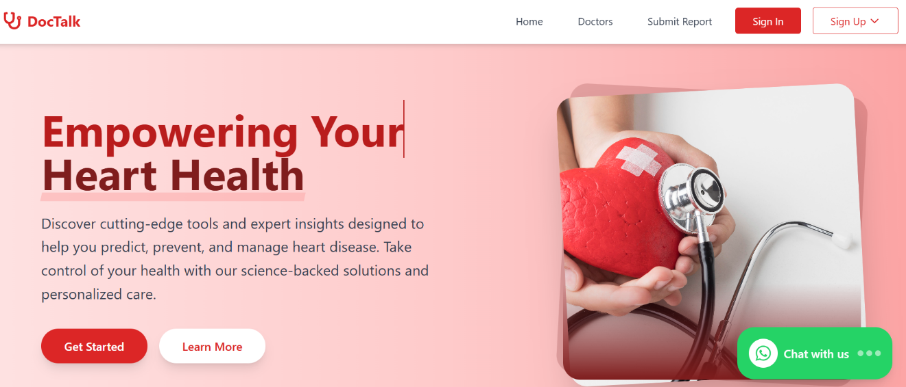

Sign in:
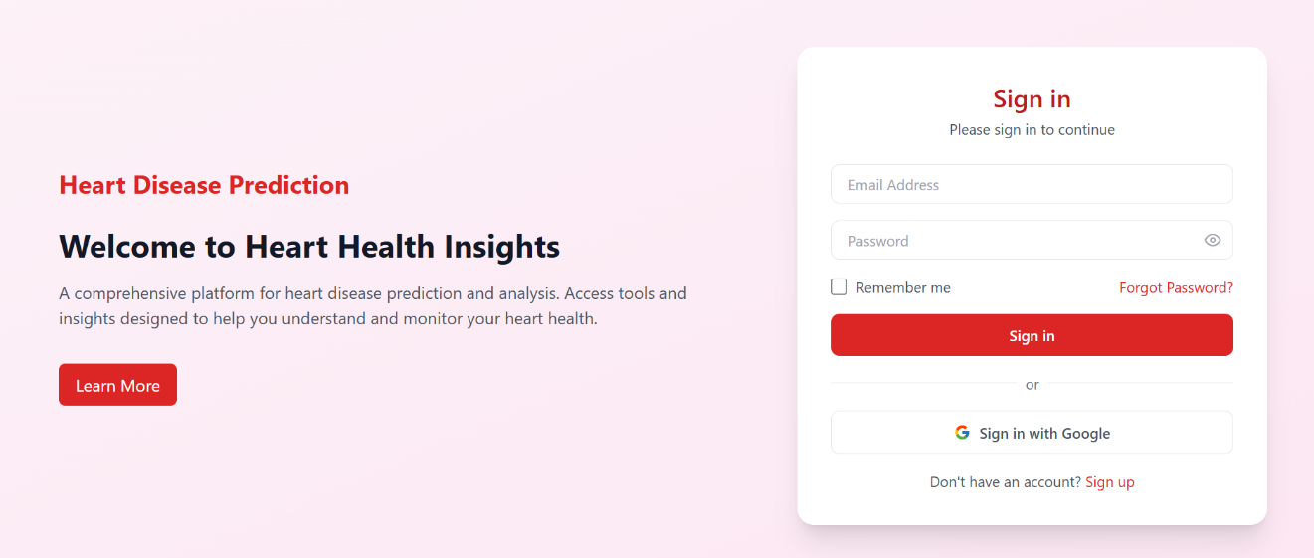

SIGN UP AS PATIENT:
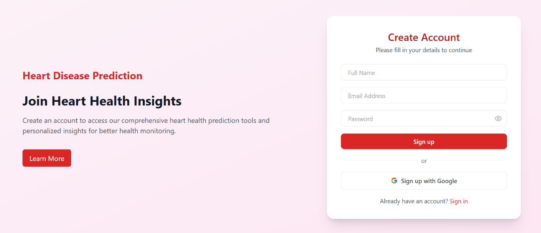

Services:

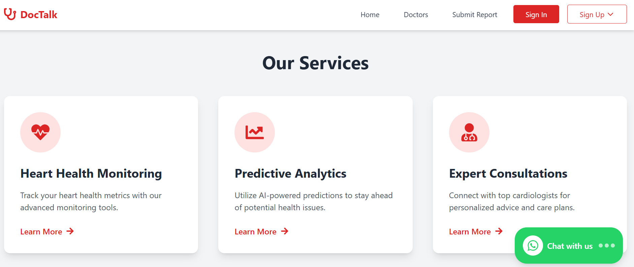

Report Submission:
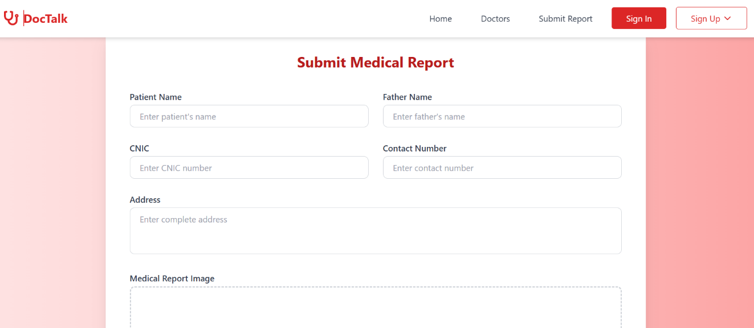

Report Image Upload:
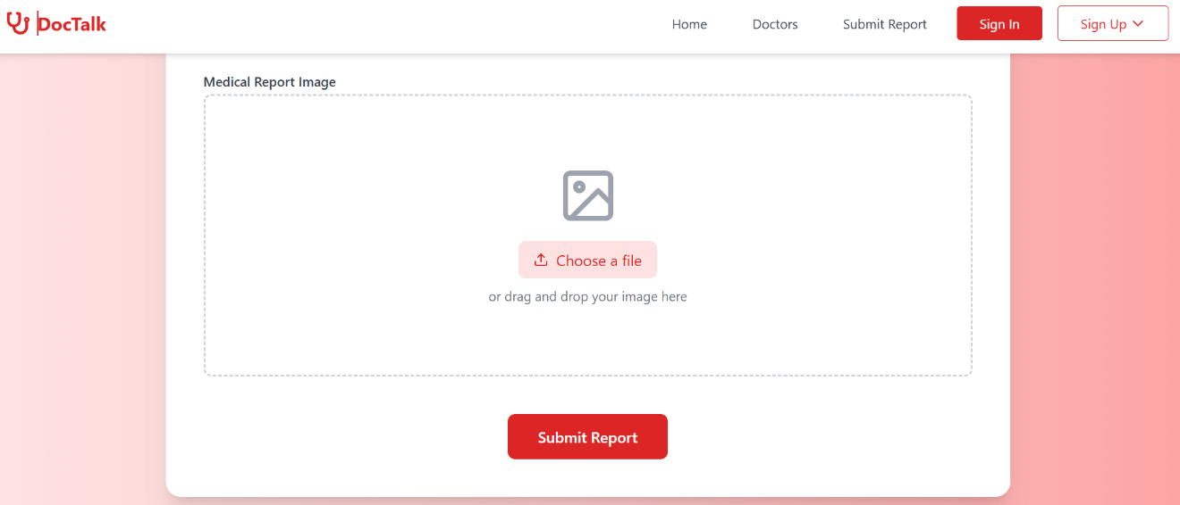

Doctor List:
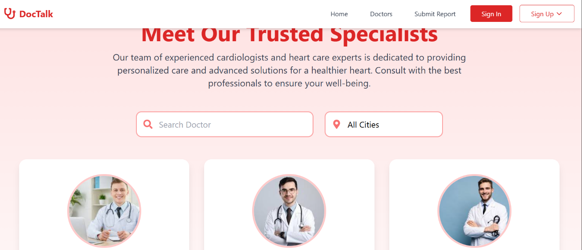

Online Doctors Consultancy:

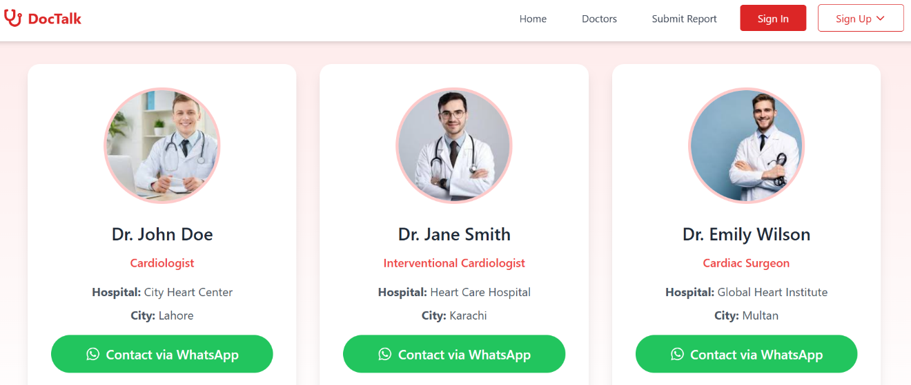

About us:
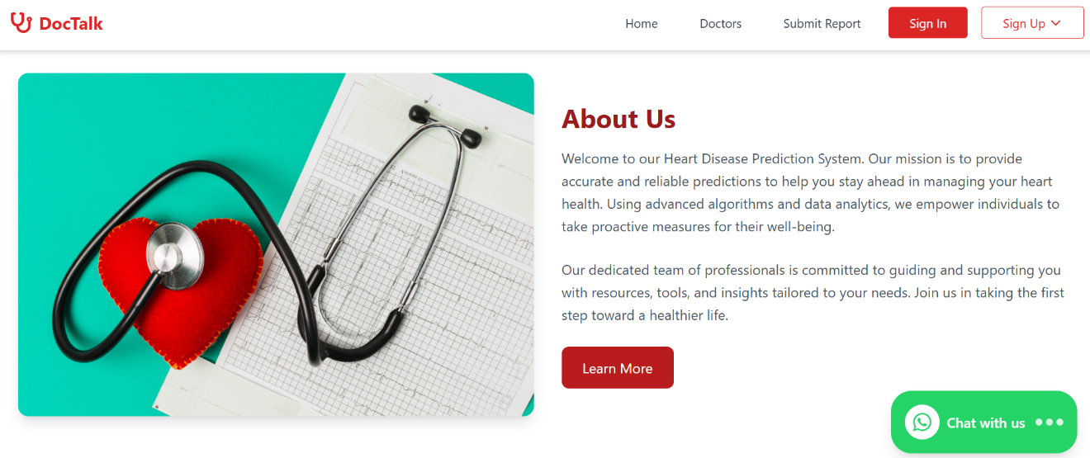

Design and Implementation

System Design
- The system will do fast work and good performance by using ML models e.g. Random forest and also responsive by reducing load time.
- Robust system handles the missing and invalid values and make them correct to make smooth working when user enter the unexpected action.
- Interactive UI made by React in simple form that has a user friendly experience for the doctor and patient
- Modular system allow easy way update it or expand it in future
Important components like ML model, API, UI modules can be reused and system can work on different platforms like mobile browser, laptop etc.
- Patient and doctor’s data is secured and protected by using PostgreSQL
In case of interactive software, the design should also consist of the following:
- Architecture Design – Interaction between components and/or modules
- Interface Design
- System Modeling – UML diagrams
- Database Design – ERD diagram

Use Case diagram:
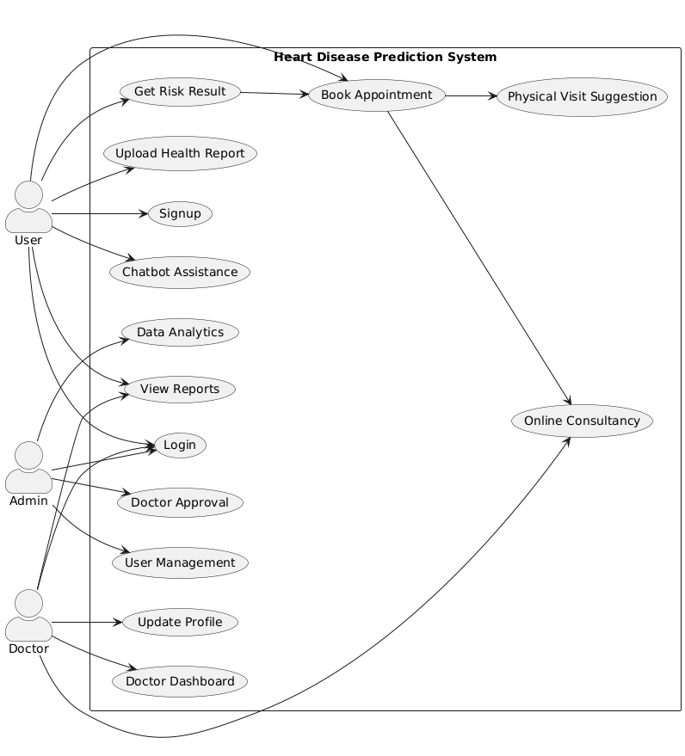

System Implementation
- Tools and Environment

- We used React for frontend, Django python for backend and PostgreSQL for storing data in database and google collab for training model.
- Our system have user verification, input as health parameters, prediction, doctor suggestion of online consultancy.
- Rest API used to connect frontend and backend.

- Model Implementation
- ML model were used to clean data and add missing values.
- Doctor and patient dashboards were made for their respective role.

- Code Standards:
  - Python code follows PEP8 standards.
  - React uses clean, reusable functional components.
  - APIs return structured JSON responses.
• Challenges & Solutions:
- Integration of the ML model was tough into Django python
- Form validation was handled using Django python and react states.
- Missing and incorrect value given by user were deal with the frontend and backend validation

The implementation section describes how the different components in the project have been implemented. It should also consist of:
- Develops tools and environment used
- Implementation of different modules (including detail steps about how they were Developed)
- Sample codes (including standards and conventions)
- Difficulties faced and how they were addressed.

Assumptions/Constraints (Optional)

Evaluation

Experimentation
This section should describe what was actually done. It is a clear exposition of the laboratory notebook, describing procedures, techniques, instrumentation, special precautions, and so on. It should be sufficiently detailed that other experienced researchers would be able to repeat the work and obtain comparable results.

Experimental Setup

Experiments Design/Details

Results
In the section, relevant data, observations, and findings are summarized. Tabulation of data, equations, charts, and figures can be used effectively to present results clearly and concisely.

Discussion/Analysis
The crux of the report is the analysis and interpretation of the results

- What do the results mean? How do they relate to the objectives of the project? To what extent have they resolved the problem?
- An evaluation of the situation – what was expected/unexpected, proved/disproved, illustrated, explored, highlighted by what you have investigated.
- Comparative Analysis: An attempt to explain the results drawing in other research/theory
- A discussion of limitations and possible sources of error

Conclusion and Future work
Heart disease prediction system and consultancy was built on machine learning based prediction system with the combination of prediction and consultancy feature to encourage the patient for visiting doctor at early stage risk of detection. It a user friendly interface that is useful for patient and doctors also and offers a real time prediction assessment after analysis of details given by patient
The main purpose of this project was to give an effective and accurate prediction and easy to use for all the people. Random forest gives the effective and high accuracy of risk prediction. A unique feature of doctor online consultancy and nearest location based doctor suggestion for physical checkup made our project more impactful and increase its value in real word use. This will improve the health care system for those who don’t have much access on health care facilities.
This will encourage the user to engage with doctor to avoid the risk of heart failure by alerting them through the prediction of risk. After seeing risk patient will ultimately go for doctor for treatment that will save the lives as much as possible.
In future we will expand our dataset to improve the accuracy and will make a mobile app based system also so this can also be accessed through the mobile apps of android and iOS. Further research may increase the more symptoms for heart failure so we will add those in to gain more accuracy as much as will be possible.

References/ Bibliography
If you have cited evidence in the main body of your report, it must be referenced in this section.
Don’t neglect references – you can lose credit if you don’t reference your sources properly.
However, you don’t need to reference:
- Common knowledge (things that most people would know)
- Undisputed historical facts
- Your own opinions, observations, and ideas – but make sure you make it clear in the report that they are your views.

Appendix

Glossary of terms

Pre-requisites

Reference/ Source Documents
Provide references to all documents that have been consulted during the project.

